|  |
| --- |
| **Lab 4: Lexemes, Identifier, Keywords.** |

Exercise 1

Write a program to split input stream in words on the basis of white spaces (white space characters: Enter, space, tab)

**Source Code:**

#include<iostream>

#include<string>

using namespace std;

int main(){

string str="hello string name ";

//cout << "Enter a string: ";

// cin >> str;

cout << "\nYou Entered: " << str << "\n\n";

string temp;

for(int i=0;i<str.length();i++)

{

if(str[i]!=' '){

temp+=str[i];

}

else{

cout<<temp<<"\n\n";

temp="";

}

}

return 0;

}

**SCREENSHOT:**

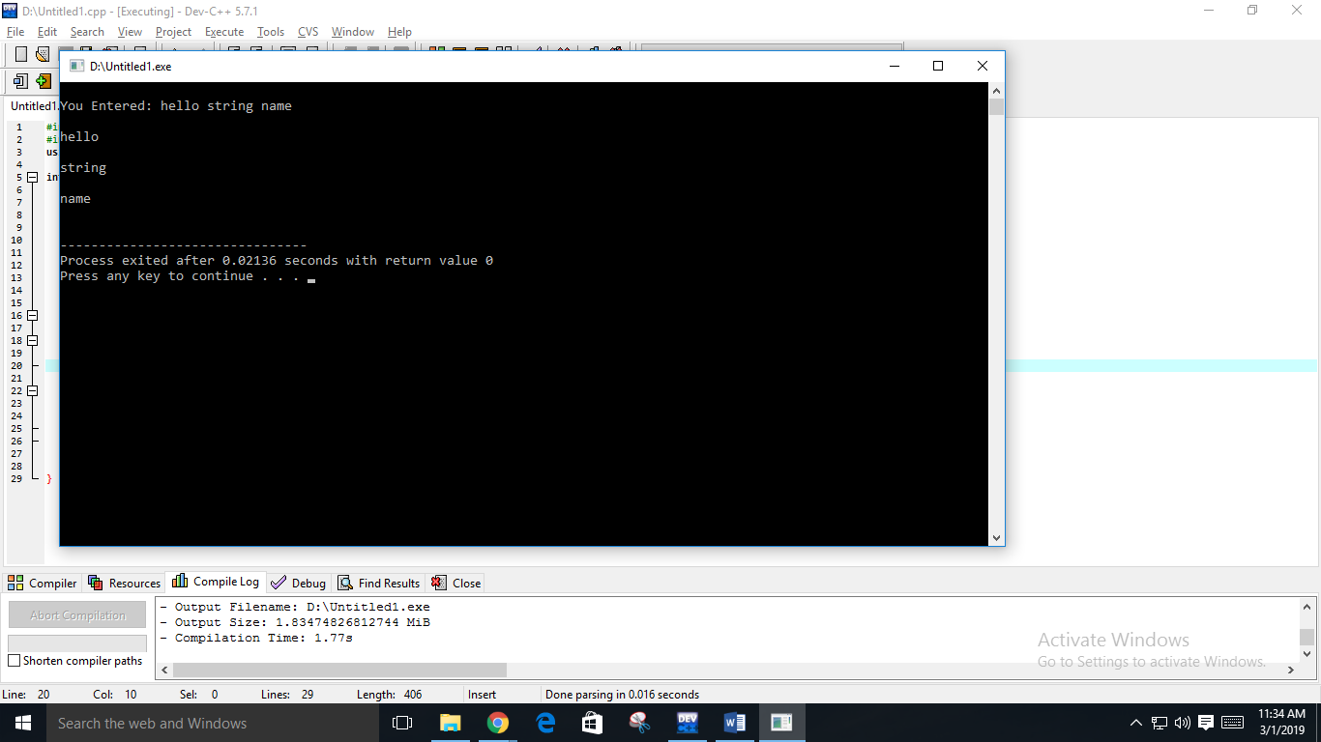

Exercise 2

Use task one code to split input stream and then write a method to recognize valid identifiers of C++.

**Source Code:**

#include<iostream>

#include<stdio.h>

#include<string.h>

using namespace std;

int transition(int s,char c){

int tt[3][3]={{1,2,2},{1,1,1},{2,2,2}};

if(c>='a'&& c<='z')

return tt[s][0];

else if(c=='_')

{

return tt[s][1];

}

else if(c>='0' && c<='9')

{

return tt[s][2];

}

else {

return -1;

}

}

int main(){

int cs=0,fs=1,i=0 ;

string s;

cin>>s;

while(s[i]!=NULL){

cs=transition(cs,s[i]);

i++;

}

if(cs==fs){

cout<<" valid identifier";}

else

cout<<" not valid accept";

}

**SCREENSHOT:**

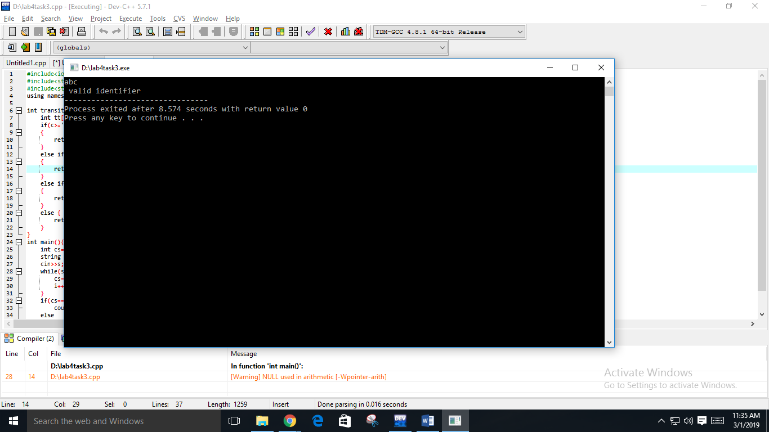

Exercise 3

Write a method to recognize valid keywords of C++.

**Sample Run:**

**Provide some input:** Area 2square Side&length

while

Area is a valid identifier

2square is an invalid identifier

Side&length is an invalid identifier

while is a keyword

**Source Code:**

#include<iostream>

using namespace std;

int main()

{

bool flag=false;

string str,b;

string keyword[6]={"while","if","int","double","float"};

cout<<"Enput any String"<<endl;

cin>>str;

for(int i=0;i<6;i++)

{

if(keyword[i]==str)

{

flag=true;

break;

}

else{

flag=false;

}

}

if(flag==true)

{

cout<<"Valid";

}

else{

cout<<"Invalid";

}

}

**SCREENSHOT:**

